Assignment 2 - Redesign a Notable Information Graphic
Redesigning Minard's Napoleon's March (1869) - An Interactive Visualization
Nisha Naresh
101008896
Ontario Tech University
Visualization & Storytelling
Gabby Resch
March 7, 2026

Project Overview
Charles Joseph Minard was a French civil engineer who has created what is generally regarded as one of the best data visualizations of all time. He created a graphic of a military campaign of destruction of Napoleon Bonaparte into Russia in 1812 more than 50 years after the events had occurred. It is not only what is depicted in this graphic but the manner in which it is depicted that can be considered the most impressive thing about it. Minard was able to encode six variables simultaneously in one image; the size of the army at that moment of the march, the route taken on the geographic map, the direction of the march, the temperature at which they froze during the retreat and the dates as well as where the important events in the army such as crossing the river and the battle took place.
Napoleon started his Russian campaign with around 422000 men, one of the biggest armies ever to be amassed by that time. When the remains of that army re-entered Poland in December of 1812 there was but about 10,000 of them. It is a loss of more than 97 per cent of the original force. Minard was able to convey this destruction using a relatively simple tool of imagery: a band which becomes narrower and narrower as the army moves eastward in the direction of Moscow, and even narrower as they move back west across the devastating Russian winter. You need not have to read one number in order to sense the burden of what transpired. So that works on you in the picture.
One of the most admired researchers in data visualization Edward Tufte was quoted saying that the graphic created by Minard was the greatest statistical graphic ever to be drawn. It has been read, quoted, and copied many a thousand times during the century and a half since it was produced. In this assignment, it is an inspiration and a beginning of something new.

Why this Graphic?
The graphic created by Minard has outlived by more than 150 years due to something that is very rare in data illustration. It does not give any explanation as it is a full story. You know what has transpired as soon as you look at it. A large force went east in great hopes brought back in nearature emptiness. The story is told all within the breadth of a band on a page and that is what makes it so powerful. Yet there is another reason why this graphic is worth studying other than its beauty. It was made with a purpose. Minard was not just writing history. He was making an argument. He was keen on making the human price of war palpable to the viewer through statistics, so that 400,000 lives lost would not be a figure in a book on history but something real, something that is visible and tangible.
As a learner of visualization and storytelling, this graphic fascinates as well since it is placed on the border of what a single image can accomplish. It is loaded with such information that it almost comes off interactive despite being frozen to death. You feel like magnifying, like seeking to enquire, to dwell into particular instances. What had happened at that crossing of the river? What a cold night they had left Moscow in? The original has no answer to such questions. It can merely give you the outlines of the disaster in a distant perspective. It is precisely that tension between the things that the graphic can and cannot do which makes it the ideal redesign to a contemporary interactive design.
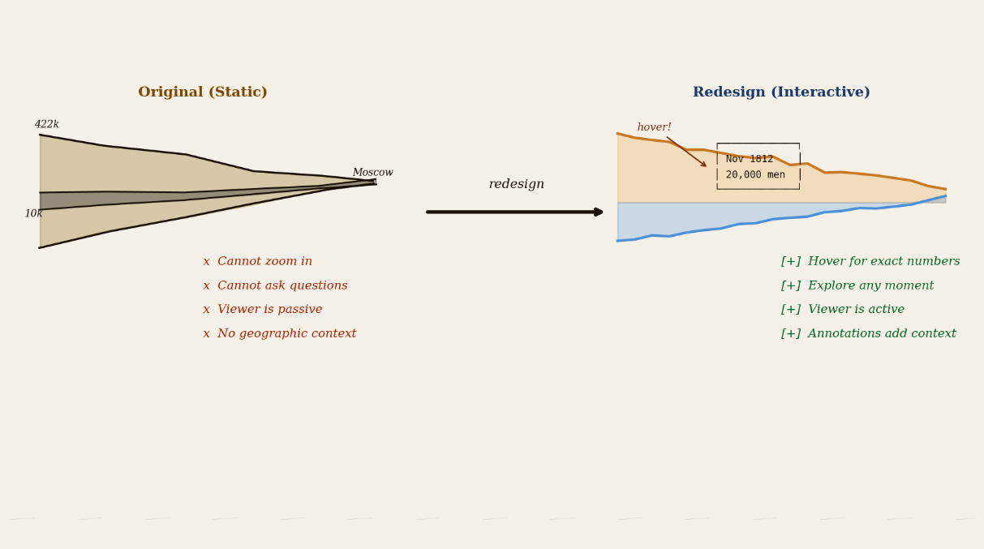

Why Redesign it?
Although Minard made a graphic that is as brilliant as it was, it was created much earlier and directed to a different audience. The individuals gazing at this illustration in 1869 were French scholars, politicians and military historians, with prior knowledge of the geography of Eastern Europe, with prior knowledge of the context of the Napoleon campaign, and with no reservation in reading intricate motionless images. Such background is no longer present in a modern general audience. A person who sees this graphic the first time today may not be able to locate Smolensk on the map, or comprehend why the crossing of the Berezina River was so huge, or even what direction the army was moving at any one time.
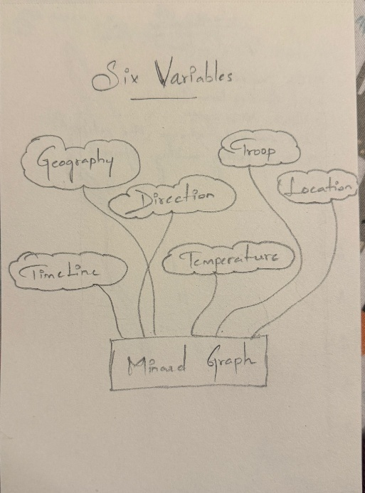
In addition to the audience problem, the format has a deeper constraint within it. Visualization scholars refer to the original graphic as a rhetorical object. It argues and presents it to you as complete. The tale has already been skin, the end has already been made, and it is but your task as the viewer to take it. One has no space to explore, question or discover anything on his/her own. The relationship is now completely altered by modern interactive visualization. When a viewer is able to fly above a point and view that 20,000 men have crossed the Berezina River in temperatures below -20 degrees Celsius, then that experience of making the personal discovery is much more effective than merely having a tiny band on a frozen map. This redesign is there to produce such moments of discovery, and to render one of the most significant pieces of data in history available and entertaining to a modern audience.

Method And Dataset
The information that was used in this redesign is based on the original graphic provided by Minard in the year 1869, which was later digitalised by a statistician known as Michael Friendly to the Histdata package, a popular collection of historical data that are used extensively in visualisation research and education. Instead of depending on an external file, the data is built right within this notebook, therefore, it will never fail to load, and no extra downloads or file management will be required.
The data is divided into two tables which are simple. The former follows the march of the army, and includes the longitude and latitude of every station on the march, the number of men that remained in the rear at that time, and whether the army was moving onward to Moscow or returning again towards Poland. The contents of the second table are the temperatures in Celsius at different points at different times of the retreat, and the date. These two tables combined portray the essence of the story that Minard had initially told, an army marching east with all the momentum and returning west as a quarter of itself in the inhuman winter conditions.

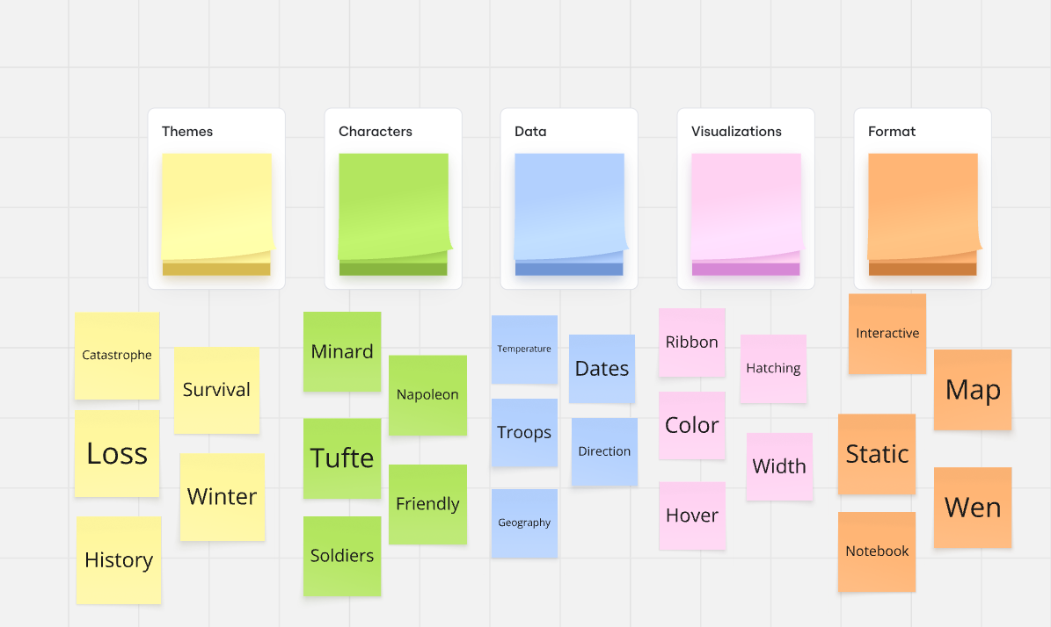

The visualisation is constructed in Python and has been done using two libraries. The first step is managed by Matplotlib, which is a prototype, not dynamic, but sets the visual implementation of the redesign as a dark background, warm amber fill of the advancing and cold steel blue of the retreat. Plotly in turn drives the resulting interactive version, which enables the viewer to query the precise troop numbers at any given point, annotate events (to connect the pivotal moments such as the Berezina River crossing to the data) and has a connected temperature subplot, to make the relationship between the cold and the casualties visible and explorable. There is no external data file to run this notebook since all the data is inbuilt and ready to run.

The Man and His Method:

Charles Joseph Minard (1781–1870)
Minard was born in Dijon in 1781. He studied at the École Polytechnique and built a long career as a civil engineer, eventually becoming Inspecteur Général des Ponts et Chaussées. He retired in 1851 and spent the following two decades producing figurative maps of trade flows, passenger volumes, and military campaigns.
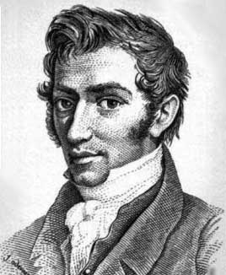
His work was largely unknown outside France during his lifetime. Robinson’s 1967 essay and Tufte’s 1983 reproduction brought the Russian campaign map to international attention more than a century after it was drawn.
Napoleon’s 1812 Russian Campaign
Napoleon crossed into Russia in June 1812 with approximately 422,000 soldiers. The campaign was intended to be swift. It was not. The Russian forces avoided pitched battle and retreated eastward, burning everything behind them. By the time the French reached Moscow in September, more than half the army was already gone.
Moscow had been evacuated and set on fire. Napoleon waited five weeks for peace overtures that never came, then ordered a retreat in October. By December, when the remnants of the army crossed back over the Niemen river, fewer than 10,000 soldiers remained. It was one of the most complete destructions of a military force in recorded history.

Analysing the original Map:

The Six Variables
Minard encoded six distinct variables in a single image using different visual channels:
- Variable 1: Geographic position: The map is geographically accurate. Cities and rivers appear at their real latitudinal and longitudinal positions.
- Variable 2: Direction of march: The advance toward Moscow is tan-brown. The retreat is black. Two colours carry the entire narrative arc.
- Variable 3: Troop count: The width of each ribbon segment is proportional to surviving soldiers at that point. This is the primary encoding.
- Variable 4: Location: Named cities appear along the ribbon at each stage of the campaign.
- Variable 5: Date: Key dates of the retreat are annotated along the lower portion.
- Variable 6: Temperature: A linked chart below plots temperature in Réaumur degrees, directly connecting cold to casualties.

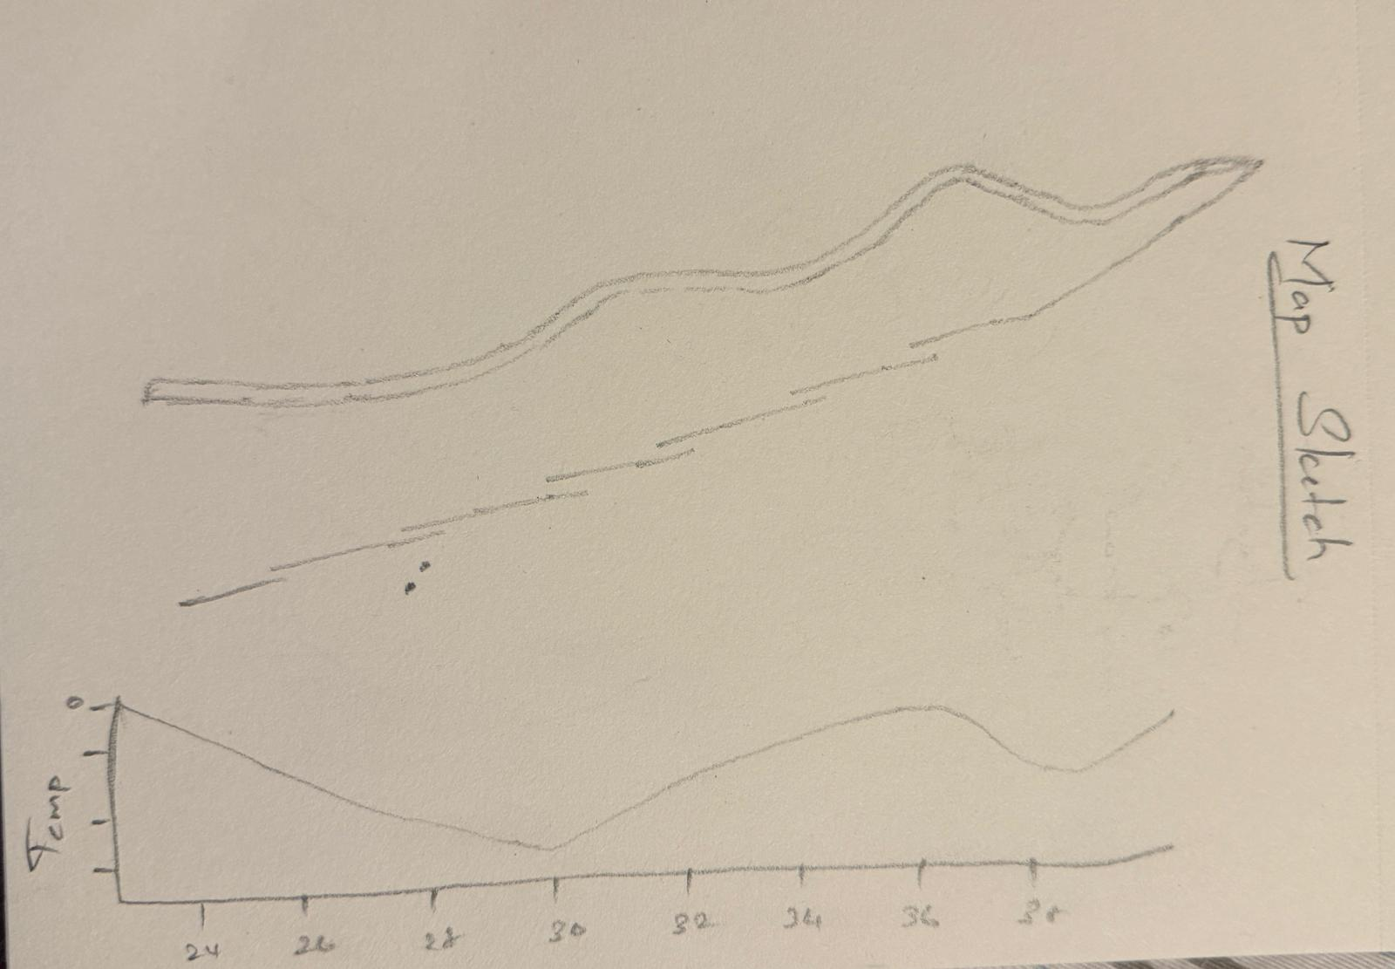

The Redesign

Design Philosophy
The begins from the principle that Minard’s core encoding must be preserved. The proportional redesign -width ribbon is not a stylistic choice; it is the argument. Any redesign that replaces it with a bar chart has lost the essential insight. The task is to extend the original rather than replace it.

Technical Approach
The redesign uses Python with Plotly for the interactive map and Matplotlib for static charts. The datasets used are the standard Minard data files: troop counts and coordinates, city names, and temperature readings.
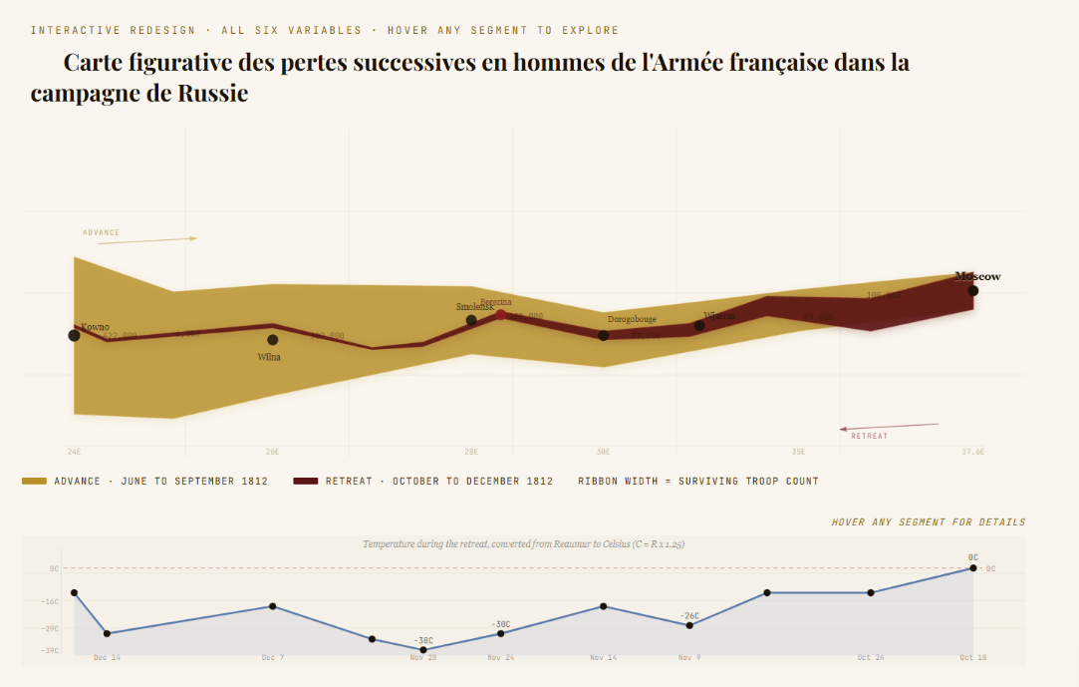

Key Decisions
- Preserved proportional width: The ribbon width remains the primary encoding. Each segment’s stroke width is scaled to the surviving troop count.
- Interactive hover annotations: Plotly allows users to hover over each waypoint and see the troop count, date, city name, and temperature.
- Celsius conversion: Réaumur values are converted using C = R × 1.25, making temperatures immediately interpretable.
- Dual-panel layout: The troop map and temperature chart are linked subplots, preserving the original insight about cold and casualties.
- Colour distinction: The advance is warm amber and the retreat is dark red, maintaining binary colour logic while improving screen contrast.

Conclusion
Working with this map as a subject reveals something easy to overlook when data visualisation is taught through templates: the most consequential choices are editorial, not technical. Minard decided that the temperature and the troop count were the two facts that mattered most. He decided that a narrowing ribbon was more powerful than a chart. He decided to leave out individual battles and the names of commanders. Every omission was an argument.

References
1: Minard, C.J. (1869). Carte figurative des pertes successives. École Nationale des Ponts et Chaussées, Paris.
2: Tufte, E.R. (1983). The Visual Display of Quantitative Information. Graphics Press.
3: Robinson, A.H. (1967). The Thematic Maps of Charles Joseph Minard. Imago Mundi, 21(1), 95–108.
4: Friendly, M. (2002). Visions and Re-visions of Charles Joseph Minard. Journal of Educational and Behavioral Statistics, 27(1), 31–51.
5: Kraak, M.J. (2014). Mapping Time: Illustrated by Minard’s Map. ESRI Press.

